Chapter 14, Problem 44.

For the circuit in Fig. 14.83, find:

(a) the resonant frequency ω₀
(b) Z_{in}(ω₀)

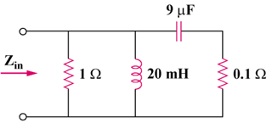

Figure 14.83
For Prob. 14.44.

